Dalton C. Brown

Olapido A. Jegede

Kali J. Nelson

Zachariah D. Pramschufer

FAMU-FSU College of Engineering  2525 Pottsdamer St. Tallahassee, FL. 32310

Team 33: Convertible High Heel Shoe Customer Needs

#### 10/5/2017

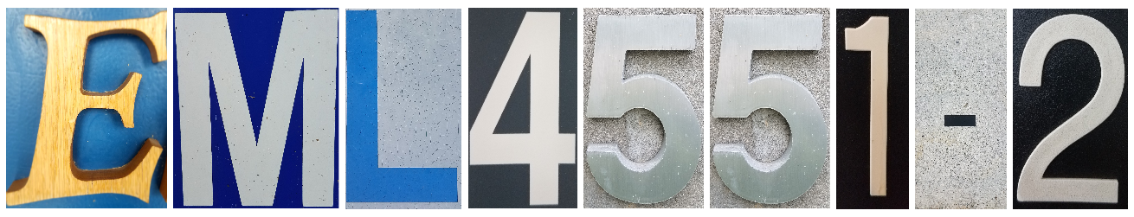

#### 

#### Table of Contents

Project Description 1

Customer Needs 1

Table 1 2

Appendix A A- 1 -

Appendix B B- 1 -

# Project Description

The main goal for our project is to provide a practical convertible shoe design that maintains a sense of fashion.

# Customer Needs

In order to determine the primary market for our product a survey was conducted via Facebook using Florida State University’s Qualtrics Survey Software. The survey Team 33 conducted was based on a survey previously given by a team in Dr. Michael Devine’s Spring 2016 Technology Entrepreneurship and Commercialization course. Many of the survey questions were reused in our survey, but a goal of our group was to determine the importance of multiple (which is defined as more than two) heights vs. modularity of parts.

The main information we wanted to gather from this survey was:

* Is this a product people would use?
* How much are people willing to pay for a convertible shoe?
* Do consumers prefer versatility over convenience?

Questions asked along with results for our survey and the previous team’s survey can be seen in the Appendix. Although sample sizes were different, the trends remained consistent in both surveys. Trends that were consistent between the two surveys include: a price point was $50 to $100, it took 1 to 3 hours for respondents feet to start hurting when wearing heels, respondents would forgo shoes and go barefoot to alleviate discomfort, and respondents would purchase a convertible shoe based on its appearance as well as overall comfort.

We evaluated the customer responses from our survey into an interpreted need which can be seen in Table 1. Customer responses were analyzed and it was found that displeasure with current heels stemmed from both discomfort and overall product functionality. The discomfort or functionality issues encountered were used as guidance for determining the potential design necessities. For instance, customers responded that it takes 1 to 3 hours for their feet to start hurting when wearing heels. The interpreted need was that our convertible shoe needed to be able to provide comfort after prolonged wear. This process was repeated for the key questions asked in the surveys.

# Table 1

*Questions Asked, Customer Response, and Interpreted Need*

|  |  |  |
| --- | --- | --- |
| Question Asked | Customer Response | Interpreted Need |
| How long does it take for your feet to start hurting when you wear heels? | 1 hour to 3 hours | The convertible shoe needs to be able to provide comfort easily after prolonged wear. |
| Have you ever walked barefoot because of the pain highs heels produced in your feet? | Yes | The convertible shoe needs to alleviate stress from the user's feet in its flat state. |
| Would you buy convertible high heel shoes? | Maybe | The convertible shoe needs to be fashionable, comfortable, and safe. |
| How much would you be willing to pay for a convertible high heel? | $50 - $100 | The price of the convertible shoe should be below $100. |
| Would you want a heel that converted into multiple heights? | Yes | The convertible shoe needs to accommodate for multiple heights. |
| Would you want a design that did not have any detachable parts? | Yes | The convertible shoe should be able to convert between heights without the user having to remove a piece. |
| Which is more important to you? (No Detachable Part or Multiple Heights) | No Detachable Part (70%)  Multiple Heights (30%) | It is more important to vary height as a singular component than as multiple components. |

# Appendix A

**Team 33’s Survey Questions and Results**

**Q1 - What is your gender?**

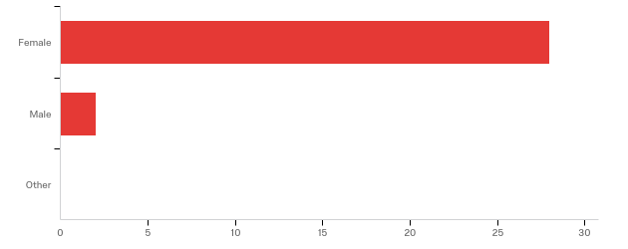

|  |  |  |  |
| --- | --- | --- | --- |
| # | Answer | % | Count |
| 1 | Female | 93.33% | 28 |
| 2 | Male | 6.67% | 2 |
| 3 | Other | 0.00% | 0 |
|  | Total | 100% | 30 |

**Q2 - What is your age?**

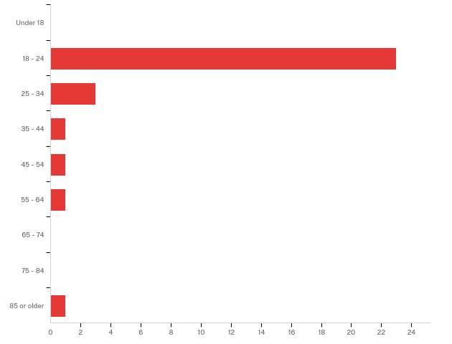

|  |  |  |  |
| --- | --- | --- | --- |
| # | Answer | % | Count |
| 1 | Under 18 | 0.00% | 0 |
| 2 | 18 - 24 | 76.67% | 23 |
| 3 | 25 - 34 | 10.00% | 3 |
| 4 | 35 - 44 | 3.33% | 1 |
| 5 | 45 - 54 | 3.33% | 1 |
| 6 | 55 - 64 | 3.33% | 1 |
| 7 | 65 - 74 | 0.00% | 0 |
| 8 | 75 - 84 | 0.00% | 0 |
| 9 | 85 or older | 3.33% | 1 |
|  | Total | 100% | 30 |

**Q3 - Have your ever worn heels?**

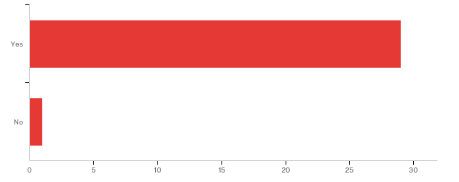

|  |  |  |  |
| --- | --- | --- | --- |
| # | Answer | % | Count |
| 1 | Yes | 96.67% | 29 |
| 2 | No | 3.33% | 1 |
|  | Total | 100% | 30 |

**Q4 - How often do you wear heels?**

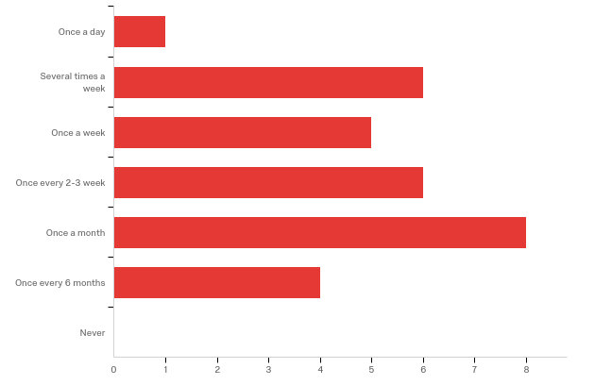

|  |  |  |  |
| --- | --- | --- | --- |
| # | Answer | % | Count |
| 1 | Once a day | 3.33% | 1 |
| 2 | Several times a week | 20.00% | 6 |
| 3 | Once a week | 16.67% | 5 |
| 4 | Once every 2-3 week | 20.00% | 6 |
| 5 | Once a month | 26.67% | 8 |
| 6 | Once every 6 months | 13.33% | 4 |
| 7 | Never | 0.00% | 0 |
|  | Total | 100% | 30 |

**Q5 - How high on average are your heels?**

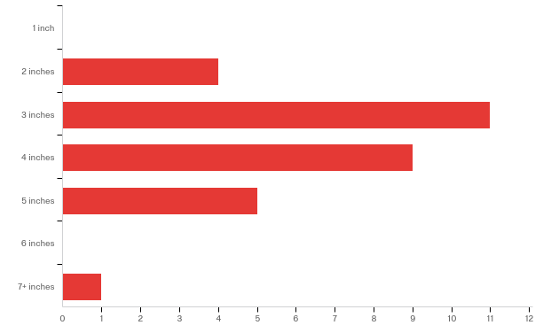

|  |  |  |  |
| --- | --- | --- | --- |
| # | Answer | % | Count |
| 1 | 1 inch | 0.00% | 0 |
| 2 | 2 inches | 13.33% | 4 |
| 3 | 3 inches | 36.67% | 11 |
| 4 | 4 inches | 30.00% | 9 |
| 5 | 5 inches | 16.67% | 5 |
| 6 | 6 inches | 0.00% | 0 |
| 7 | 7+ inches | 3.33% | 1 |
|  | Total | 100% | 30 |

**Q6 - How much do your feet hurt after wearing high heels?**

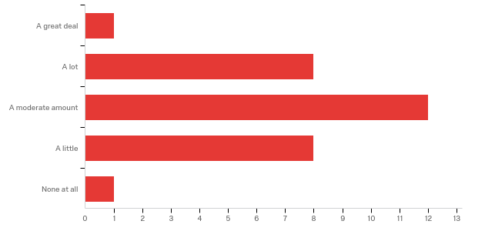

|  |  |  |  |
| --- | --- | --- | --- |
| # | Answer | % | Count |
| 1 | A great deal | 3.33% | 1 |
| 2 | A lot | 26.67% | 8 |
| 3 | A moderate amount | 40.00% | 12 |
| 4 | A little | 26.67% | 8 |
| 5 | None at all | 3.33% | 1 |
|  | Total | 100% | 30 |

**Q7 - How much on average do you spend on a pair of heels?**

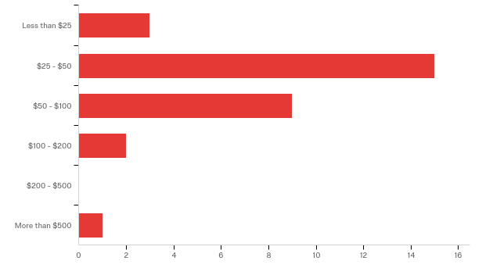

|  |  |  |  |
| --- | --- | --- | --- |
| # | Answer | % | Count |
| 1 | Less than $25 | 10.00% | 3 |
| 2 | $25 - $50 | 50.00% | 15 |
| 3 | $50 - $100 | 30.00% | 9 |
| 4 | $100 - $200 | 6.67% | 2 |
| 5 | $200 - $500 | 0.00% | 0 |
| 6 | More than $500 | 3.33% | 1 |
|  | Total | 100% | 30 |

**Q8 - How often do you carry a pair of flat shoes with you when you will be wearing heels for an extended period?**

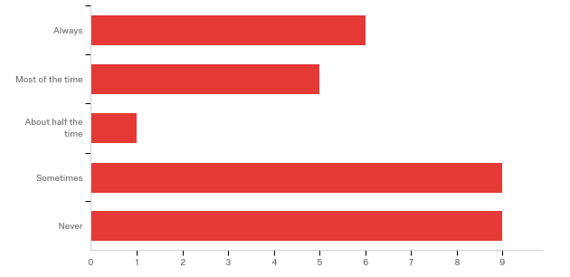

|  |  |  |  |
| --- | --- | --- | --- |
| # | Answer | % | Count |
| 1 | Always | 20.00% | 6 |
| 2 | Most of the time | 16.67% | 5 |
| 3 | About half the time | 3.33% | 1 |
| 4 | Sometimes | 30.00% | 9 |
| 5 | Never | 30.00% | 9 |
|  | Total | 100% | 30 |

**Q9 - Have your feet ever hurt so bad that you removed your heels and walked barefoot?**

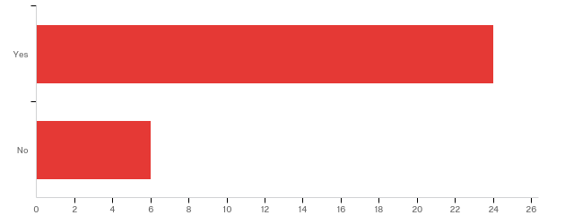

|  |  |  |  |
| --- | --- | --- | --- |
| # | Answer | % | Count |
| 1 | Yes | 80.00% | 24 |
| 2 | No | 20.00% | 6 |
|  | Total | 100% | 30 |

**Q10 - Have you ever heard of a convertible high heel shoe?**

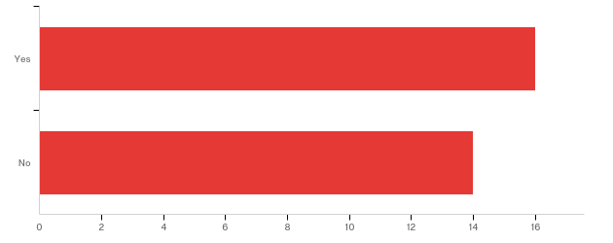

|  |  |  |  |
| --- | --- | --- | --- |
| # | Answer | % | Count |
| 1 | Yes | 53.33% | 16 |
| 2 | No | 46.67% | 14 |
|  | Total | 100% | 30 |

**Q11 - Would you purchase a pair of heels that converted into a flat shoe?**

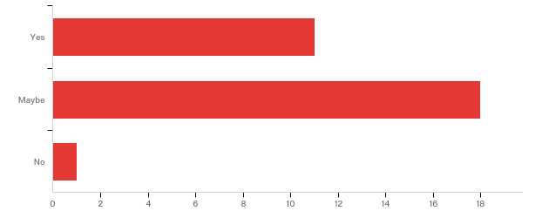

|  |  |  |  |
| --- | --- | --- | --- |
| # | Answer | % | Count |
| 1 | Yes | 36.67% | 11 |
| 2 | Maybe | 60.00% | 18 |
| 3 | No | 3.33% | 1 |
|  | Total | 100% | 30 |

**Q12 - Would you want a design that did not have any detachable parts in order to convert from heel to flat?**

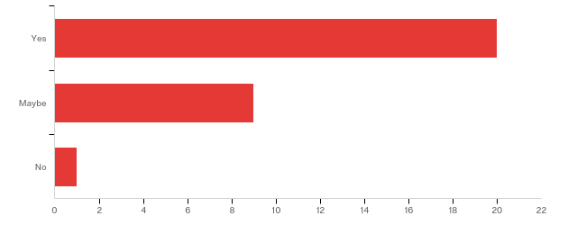

|  |  |  |  |
| --- | --- | --- | --- |
| # | Answer | % | Count |
| 1 | Yes | 66.67% | 20 |
| 2 | Maybe | 30.00% | 9 |
| 3 | No | 3.33% | 1 |
|  | Total | 100% | 30 |

**Q13 - Would you want a heel that converted into multiple heights?**

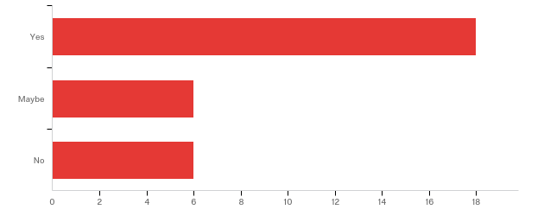

|  |  |  |  |
| --- | --- | --- | --- |
| # | Answer | % | Count |
| 1 | Yes | 60.00% | 18 |
| 2 | Maybe | 20.00% | 6 |
| 3 | No | 20.00% | 6 |
|  | Total | 100% | 30 |

**Q14 - Which quality is more important to you?**

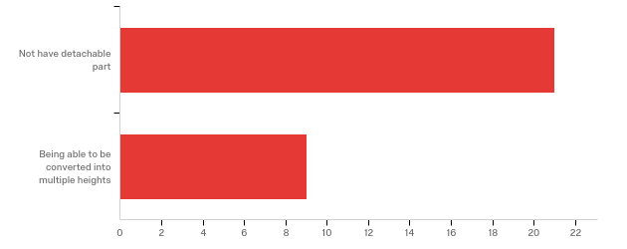

|  |  |  |  |
| --- | --- | --- | --- |
| # | Answer | % | Count |
| 1 | Not have detachable part | 70.00% | 21 |
| 2 | Being able to be converted into multiple heights | 30.00% | 9 |
|  | Total | 100% | 30 |

**Q15 - Why did you pick that answer for the question above?**

|  |
| --- |
| Why did you pick that answer for the question above? |
| it offers a variety of ways to be used |
| So I don't have to keep track of the pieces of my heels when I'm drunk and don't want to be in heels anymore |
| Variation on uses |
| I would rather not have to carry around an extra part. |
| I love the height that heels provide, but the height depends on the ocassion and place. |
| Because the shoe would be multifaceted |
| I'd be likely to lose a detachable piece. |
| So I don’t have to carry extra stuff in my purse |
| I would loose the detachable part in an instant, super inconvenient |
| I don’t want to have to carry around a piece of my shoe and worry about loosing it. |
| i don't like carrying extra shoes when I wear heels so i def dont wanna be in charge of extra moving parts |
| Versatility! |
| I lose things a lot so I wouldn't want to lose a part of my shoe |
| If it detaches it’s more to carry |
| I'm tall so high heels of any height accomplish what I'm looking for. Not having detachable parts is more important because I go out when I wear heels, and don't want to have to carry anything else. |
| I would lose parts |
| it's easy to lose pieces!! lol |
| I would lose the detachable part eventually. |
| I would wear the heel for the height initially but I wouldn’t want to wear a shorter heel when my feet hurt, just a flat shoe. |
| Detachable things get lost |
| Nothing to carry around |
| bc im poor and a girl |

**Q16 - What price would you be willing to pay for a convertible high heel?**

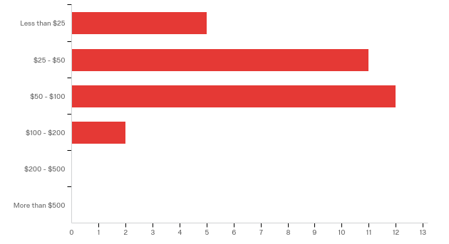

|  |  |  |  |
| --- | --- | --- | --- |
| # | Answer | % | Count |
| 1 | Less than $25 | 16.67% | 5 |
| 2 | $25 - $50 | 36.67% | 11 |
| 3 | $50 - $100 | 40.00% | 12 |
| 4 | $100 - $200 | 6.67% | 2 |
| 5 | $200 - $500 | 0.00% | 0 |
| 6 | More than $500 | 0.00% | 0 |
|  | Total | 100% | 30 |

**Q17 - How long does it take for your feet to start hurting when you wear heels?**

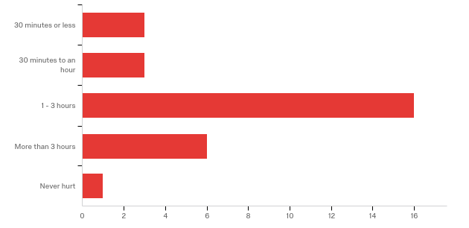

|  |  |  |  |
| --- | --- | --- | --- |
| # | Answer | % | Count |
| 1 | 30 minutes or less | 10.34% | 3 |
| 2 | 30 minutes to an hour | 10.34% | 3 |
| 3 | 1 - 3 hours | 55.17% | 16 |
| 4 | More than 3 hours | 20.69% | 6 |
| 5 | Never hurt | 3.45% | 1 |
|  | Total | 100% | 29 |

# Appendix B

**Previous Group’s Survey Questions and Results**

 